Arris DG3270A/NA [32/38] Resetting the router to factory defaults

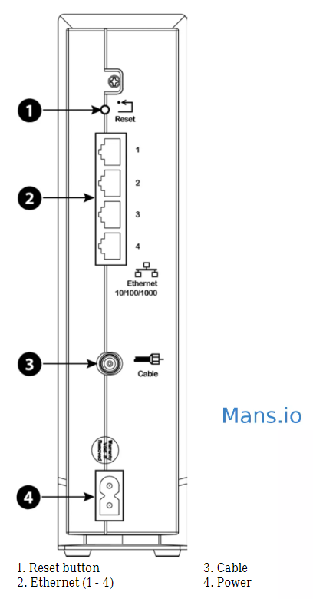

Resetting the Router to Factory Defaults
To reset the router to factory defaults, press and hold the Reset button (1) on the back of
the Data Gateway for more than fifteen seconds. This restores the wireless setup
configuration and router configuration parameters to the factory defaults. You may need to
do this if a misconfiguration has locked out all access.

How to Reset the Arris DG3270 router:
- Make sure the router is ON.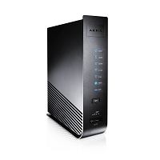
- Find a small hole at the back of the router. That is the Reset hole.
- Get a straightened paperclip, a push pin or anything pointy and thin.
- Push the Reset hole in for at least 10-15 seconds.
- Wait for the router to reboot and reconnect.

How to login to the Arris DG3270 router
To login into the DG3270 and change the settings:
- Open your browser and visit http://10.0.0.138
- You should see the login screen.
- Enter the username: admin and the password: password.

Download the Arris DG3270 Manual
Click the link below to start your download:
- Arris DG3270 Manual

